*vivo mobile*

vivo y21

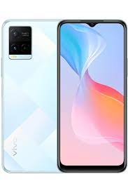

**vivo Y21** ; Size, 6.51 inches, 102.3 cm2 (~81.8% screen-to-body ratio) ; Resolution, 720 x 1600 pixels, 20:9 ratio (~270 ppi density) ; OS, Android 11, Funtouch..

**PRICE / 59,699 PRK**